Example: Global Friend classes
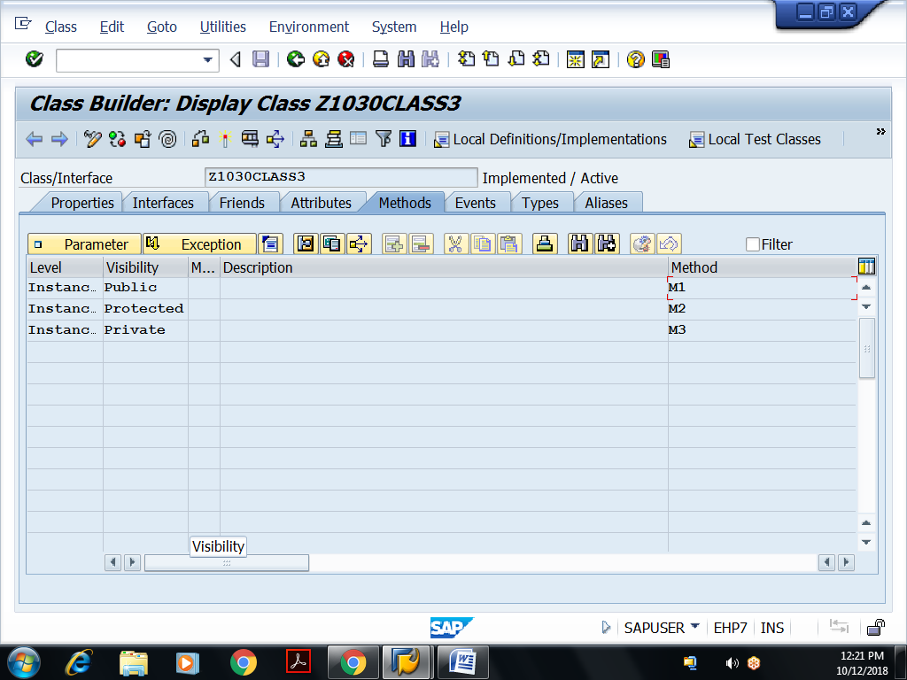
Implementations of methods:
method M1.
write :/ 'Inside instance public method m1 of class3...'.
endmethod.
method M2.
write :/ 'Inside instance protected method m2 of class3...'.
endmethod.
method M3.
write :/ 'Inside instance private method m3 of class3...'.
endmethod.
Save, activate the global class
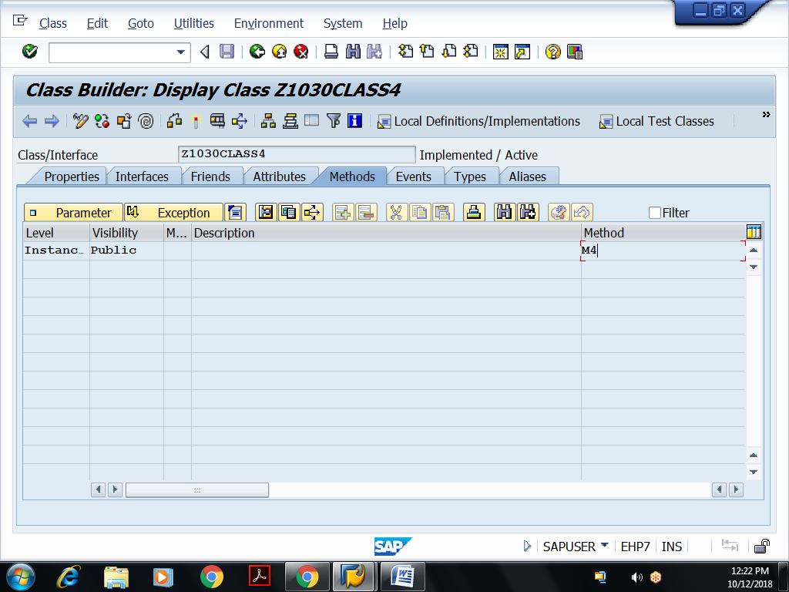
Implementation of Method:
method M4.
write :/ 'Inside Instance public method m4 of class 4...'.
data k type ref to z1030class3.
create object k.
call method k->m1.
call method k->m2.
call method k->m3.
endmethod.
Executable Program:
REPORT Z1030OOPS10.
data ob type ref to z1030class4.
create object ob.
call method ob->m4.

